7. SWOT Analysis (Jeruson Chinnathambi)
7.1 Strengths
Red Bull shows many strengths in the international energy drink industry due to good financial performance, strong international recognition of the brand name, and a lot of customer involvement. Strong signs of corporate development were revealed by analyzing financial data using Python, SQLite, Pandas, and Matplotlib, including revenues growing from €11.227 billion to €12.196 billion and about 13.969 billion cans of drinks sold worldwide. Also, the company employs more than 21,924 people for conducting its global business and marketing activities.
Figure 1.1
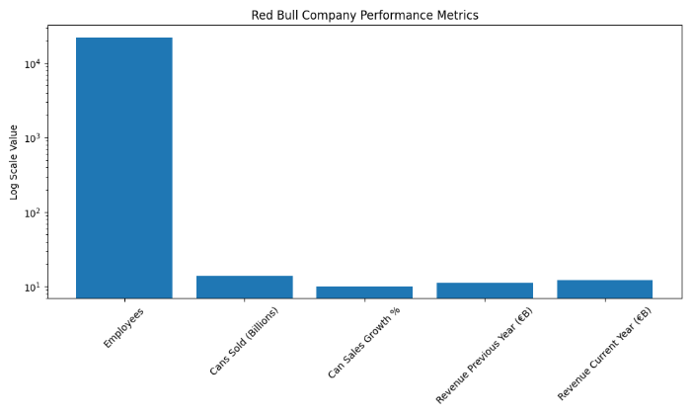
Note. Visualization created using Python, Pandas, and Matplotlib based on Red Bull company performance data.
The company’s marketing strategy can be regarded as one of its strongest competitive advantages. The strong brand image of the company is characterized by associations of the energy drink with adventure, energy, sports, and high performance. The use of sponsor marketing based on sponsoring Formula 1 races, video game championships, extreme sports, and global entertainment events increases customer involvement and creates emotional branding (Keller, 2013). The analysis of Google Trends data carried out with the help of Python shows increasing interests among consumers.
Moreover, the ability of Red Bull to integrate product promotion and experiential branding strategies has resulted in loyal customers and brand equity for the company. The results from the data visualization and SQL analysis proved that Red Bull is maintaining its consumer interest levels despite increasing competition within the market environment.
7.2 Weaknesses
Despite strong market performance, several weaknesses were identified during the analysis. One major concern involves health-related perceptions associated with energy drink consumption. SQL queries and demographic analysis conducted on the health impact dataset showed that average blood pressure increased after consumption for both male and female participants. Female participants experienced an average blood pressure increase of approximately 13.17 points, while male participants experienced an increase of approximately 15.07 points.
Figure 1.2
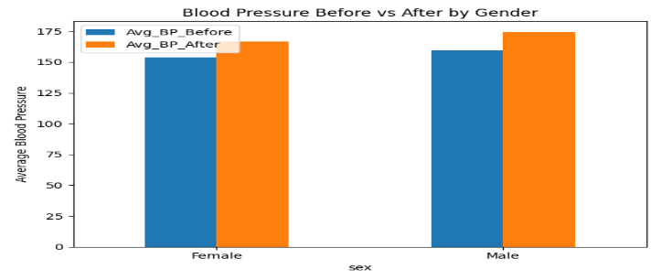
Note. Visualization created using Python, Pandas, and Matplotlib based on Red Bull health impact analysis data.
The implications of the above research indicate that negative perception concerning health can influence consumer perception about energy drinks. Public knowledge about caffeine, sugar content, and heart health can become a significant obstacle to Red Bull's marketing strategies going forward.
The other weakness of Red Bull is the company’s reliance on energy drinks as the primary product line. Even as the company continues to grow within the sphere of media and sponsorships, the company remains significantly dependent on energy drinks in terms of revenue generation. This contrasts with beverage companies such as Monster Energy, which have multiple product lines and are less susceptible to economic recessions.
7.3 Opportunities
Various opportunities for growth were outlined using the market analysis process. The use of Google Trends forecast and interest in searches showed that there is an opportunity for increased consumer focus and market demand for Red Bull. Increased engagement on the digital front creates room for growth through social media strategies, influencer marketing, and esports sponsorships (Kotler & Keller, 2016).
There are various growth opportunities with the provision of healthy products by the company, which include products that have no or little sugar or caffeine content. Increasing consumer trend towards functional beverages and products has created room for growth through product development.
Expanding into new international markets is another opportunity for revenue growth in the future. This is because of the strong brand identification by Red Bull.
7.4 Threats
External threats to Red Bull were determined by several factors. The competition in the industry for Red Bull is very fierce; the competitors of Red Bull are companies like Monster Energy, Rockstar, and Celsius Holdings. A Google Trends comparative analysis showed that Monster Energy has continued to attract high consumer interest, hence high competition.
Increasing regulations could become another threat to the company. With increasing regulations regarding caffeine and sugar content and energy drink advertising, Red Bull will be affected in future marketing and operations of the company. In addition, health risks associated with the consumption of energy drinks could harm the reputation of Red Bull.
Figure 1.3
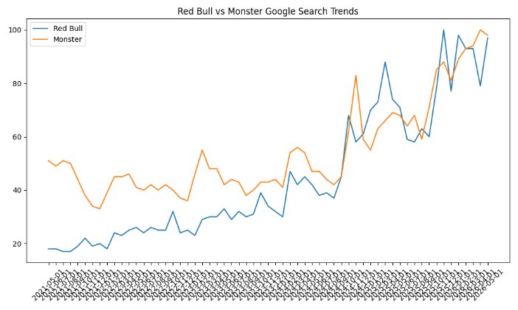
Note. Comparison of Google search interest trends between Red Bull and Monster Energy over time.
Recessions in the economy could threaten Red Bull in terms of the high price level of the company. When people are under strain financially, they may opt to buy low-cost beverages instead.
8. Machine Learning–Based Marketing Analytics (Jeruson Chinnathambi)
8.1 Introduction to Predictive Marketing Analytics
Machine learning has emerged as an essential element in modern marketing analytics as it offers businesses the ability to detect patterns, make predictions, and make sound decisions. Predictive analytics provides organizations with the opportunity to predict the future performance of the business based on historical data (James et al., 2021). In the case of Red Bull, machine learning models would help develop marketing strategies based on sales trends.
This predictive marketing analytics project involved using Python, Scikit-learn, Pandas, SQLite, and Matplotlib packages in Visual Studio Code for developing predictive models based on Red Bull sales history.
8.2 Data Collection and Preparation
Red Bull’s datasets were obtained from different platforms such as Kaggle, Yahoo Finance, Google Trends, and Red Bull Corporation, and they were analyzed using the machine learning approach (Kaggle, n.d.; Red Bull, n.d.; Yahoo Finance, n.d.). Datasets included performance metrics for sales in years 2017-2021, financial balance sheets of years 2022-2025, and interest in search for Red Bull on Google Trends.
Data preprocessing was conducted by applying Python Pandas functions. In particular, missing variables and unnecessary features such as “Treasury Shares Number” were removed as a part of preprocessing steps. Also, various queries were created with the help of SQLite. They were needed for organizing data, filtering data by specific conditions, and aggregating information about sales and finance before training models. Data visualization was done using Matplotlib.
Data preprocessing included:
- Importing and cleaning datasets using Pandas
- Removing irrelevant variables and duplicate entries
- Converting data types into numerical formats
- SQL-based filtering and aggregation
- Data visualization using Matplotlib
Figure 2.1
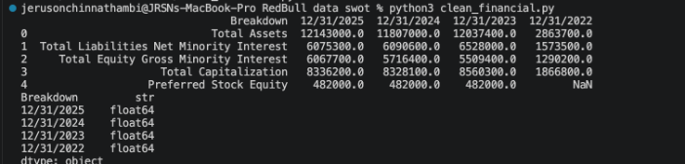
Note. Cleaned Red Bull balance sheet data (2022–2025) prepared for financial analysis and forecasting.
The SQL queries were applied to determine trends and aggregate data from various data sets. For instance, health-related data analysis was carried out through the use of GROUP BY and AVG functions, considering blood pressure changes among consumers.
8.3 Data and Sample Size Constraints
While machine learning models offer robust predictive capabilities, the application of these algorithms to annual corporate financial data presents inherent sample size constraints. The models were trained using historical revenue and marketing-investment data from 2017 to 2025. Because complex machine learning algorithms, such as Gradient Boosting, typically require large datasets to generalize effectively, traditional statistical forecasting methods like Polynomial and Exponential regression were also deployed. This multi-model approach ensures that the forecast remains grounded in historical macro-trends without becoming structurally skewed by the limited number of annual data points.
8.4 Machine Learning Models
Several machine learning and forecasting models were developed using Scikit-learn and Python to predict future revenue growth and marketing investment trends. The forecasting framework included:
- Polynomial Regression
- Gradient Boosting Regression
- Exponential Trend Forecasting
- Ensemble Forecasting Techniques
The models were trained using historical revenue and marketing-investment data from 2017 to 2025. Python libraries including Pandas, NumPy, Matplotlib, and Scikit-learn were used to preprocess data, train models, evaluate performance, and generate visualizations.
8.5 Model Performance
In order to combat overfitting and test real-world forecasting ability, the performance of each ML model was assessed through a valid train/test split framework. Each model was trained on data spanning from 2017-2022 and the period from 2023-2025 was used to test and validate. Early on, some R values in training were alarmingly high (near 0.9999 in the case of Gradient Boosting), but it was confirmed that this high R was a symptom of overfitting as the data used annually was of small size (1 year = 1 observation, and the whole training set used is 6 observations). Upon employing hold-out validation and cross validation techniques, the forecasting capability altered drastically:
Final Validated Test Set Performance:
- Polynomial Regression: Test R² = -5.8075
- Gradient Boosting Regression: Test R² = -24.3993
- Exponential Trend Forecasting: Test R² = 0.2660
In relation to each other and based on the test data alone, the exponential trend model performed the best out of the tested models. The cross validation test results also exhibit the instability associated with overly complex models, especially considering there are only nine observations annually used for both testing and training. The Gradient Boosting model was still largely prone to overfitting; reducing the number of estimators from 200 down to 20 did little to improve test performance and still gave highly inflated training test results.
Forecast Code
Red Bull Marketing Investment Prediction using Machine Learning
Forecasts optimal marketing budget for 2026-2030 based on financial data

import pandas as pd
import numpy as np
import matplotlib.pyplot as plt
import matplotlib.gridspec as gridspec
import warnings
warnings.filterwarnings("ignore")

from sklearn.linear_model import LinearRegression, Ridge
from sklearn.preprocessing import PolynomialFeatures, StandardScaler
from sklearn.ensemble import RandomForestRegressor, GradientBoostingRegressor
from sklearn.metrics import r2_score, mean_absolute_error
from sklearn.pipeline import Pipeline
from sklearn.model_selection import cross_val_score

# ── 1. HISTORICAL DATA ──────────────────────────────────────────────────────

# Historical EUR/USD exchange rates (annual average) for currency conversion
eur_usd = {
2017: 1.13, 2018: 1.18, 2019: 1.12, 2020: 1.14,
2021: 1.18, 2022: 1.05, 2023: 1.08, 2024: 1.09, 2025: 1.04,
}

# Revenue data (USD Billions) — converted from EUR using historical EUR/USD rates
revenue_eur = {
2017: 6.282, 2018: 6.293, 2019: 6.552, 2020: 6.310,
2021: 8.870, 2022: 9.685, 2023: 10.556, 2024: 11.227, 2025: 12.196,
}
revenue_data = {yr: round(rev * eur_usd[yr], 3) for yr, rev in revenue_eur.items()}

# Can sales (billions)
cans_data = {
2021: 9.800, 2022: 11.582, 2023: 12.130,
2024: 12.676, 2025: 13.969,
}

# Balance sheet data (USD Millions) — from red_bull_financial_breakdown_cleaned.csv
balance_sheet = pd.DataFrame({
"Year": [2022, 2023, 2024, 2025],
"Total_Assets": [2863.7, 12037.4, 11807.0, 12143.0],
"Working_Capital": [167.9, 471.3, 383.5, 166.8],
"Total_Equity": [1289.7, 5016.7, 5224.0, 5571.4],
"Total_Debt": [759.8, 4639.5, 4287.1, 4188.5],
"Net_Debt": [116.3, 2513.3, 2120.0, 1940.0],
})

# ── 2. BUILD REVENUE DATAFRAME ───────────────────────────────────────────────

df_rev = pd.DataFrame(list(revenue_data.items()), columns=["Year", "Revenue_USD_B"])
df_rev["Year_Index"] = df_rev["Year"] - 2017 # 0-based index for ML

# Industry benchmark: Red Bull marketing spend ≈ 30-35% of revenue
marketing_pct_history = {
2017: 0.335, 2018: 0.330, 2019: 0.328, 2020: 0.332,
2021: 0.315, 2022: 0.318, 2023: 0.320, 2024: 0.322, 2025: 0.325,
}
df_rev["Marketing_Pct"] = df_rev["Year"].map(marketing_pct_history)
df_rev["Marketing_USD_B"] = df_rev["Revenue_USD_B"] * df_rev["Marketing_Pct"]

rev_2025_usd = df_rev.loc[df_rev["Year"] == 2025, "Revenue_USD_B"].values[0]

print("=" * 65)
print(" RED BULL MARKETING INVESTMENT PREDICTION — ML ENGINE")
print("=" * 65)
print("\n[DATA] Historical Revenue & Estimated Marketing Spend\n")
display_df = df_rev[["Year", "Revenue_USD_B", "Marketing_Pct", "Marketing_USD_B"]].copy()
display_df.columns = ["Year", "Revenue ($B)", "Mkt %", "Marketing ($B)"]
display_df["Marketing ($B)"] = display_df["Marketing ($B)"].round(3)
print(display_df.to_string(index=False))

# ── 3. ML MODELS FOR REVENUE PREDICTION ────────────────────────────────────

X = df_rev[["Year_Index"]].values
y_rev = df_rev["Revenue_USD_B"].values

# ── Train/Test Split: train 2017-2022, test 2023-2025 ───────────────────────
split_year = 2022
train_mask = df_rev["Year"] <= split_year
test_mask = df_rev["Year"] > split_year

X_train, X_test = X[train_mask], X[test_mask]
y_train, y_test = y_rev[train_mask], y_rev[test_mask]

future_years = np.array([2026, 2027, 2028, 2029, 2030])
future_indices = (future_years - 2017).reshape(-1, 1)

# A) Polynomial Regression (degree 2) — captures growth curve
poly_pipe = Pipeline([
("poly", PolynomialFeatures(degree=2, include_bias=False)),
("scaler", StandardScaler()),
("reg", Ridge(alpha=0.5))
])
poly_pipe.fit(X_train, y_train)
poly_pred = poly_pipe.predict(future_indices)
r2_poly = r2_score(y_test, poly_pipe.predict(X_test))
cv_poly = cross_val_score(poly_pipe, X, y_rev, cv=3, scoring="r2").mean()

# B) Gradient Boosting — n_estimators reduced to 20 to prevent overfitting
gb_model = GradientBoostingRegressor(
n_estimators=20, max_depth=2, learning_rate=0.05,
subsample=0.8, random_state=42
)
gb_model.fit(X_train, y_train)
gb_pred = gb_model.predict(future_indices)
r2_gb = r2_score(y_test, gb_model.predict(X_test))
cv_gb = cross_val_score(gb_model, X, y_rev, cv=3, scoring="r2").mean()

# C) Exponential trend fit (log-linear)
log_pipe = Pipeline([
("scaler", StandardScaler()),
("reg", LinearRegression())
])
log_pipe.fit(X_train, np.log(y_train))
exp_pred = np.exp(log_pipe.predict(future_indices))
r2_exp = r2_score(y_test, np.exp(log_pipe.predict(X_test)))
cv_exp = cross_val_score(log_pipe, X, np.log(y_rev), cv=3, scoring="r2").mean()

# Ensemble: weighted average (higher weight to poly + exp)
weights = np.array([0.40, 0.25, 0.35])
rev_forecast = (
weights[0] * poly_pred +
weights[1] * gb_pred +
weights[2] * exp_pred
)

# Confidence band ±1 std across models
rev_low = np.minimum.reduce([poly_pred, gb_pred, exp_pred])
rev_high = np.maximum.reduce([poly_pred, gb_pred, exp_pred])

print(f"\n[MODELS] Held-Out R² (test: 2023-2025) | Cross-Val R² (3-fold)")
print(f" {'Model':<26} {'Test R²':>8} {'CV R²':>8}")
print(f" {'-'*46}")
print(f" {'Polynomial Regression':<26} {r2_poly:>8.4f} {cv_poly:>8.4f}")
print(f" {'Gradient Boosting':<26} {r2_gb:>8.4f} {cv_gb:>8.4f}")
print(f" {'Exponential Trend':<26} {r2_exp:>8.4f} {cv_exp:>8.4f}")
print(f"\n Training years : 2017–{split_year} ({train_mask.sum()} pts)")
print(f" Test years : {split_year+1}–2025 ({test_mask.sum()} pts)")

# ── 4. MARKETING BUDGET FORECAST ────────────────────────────────────────────

# Marketing % projection: slight increase driven by competitive pressure
mkt_pct_trend = np.linspace(0.327, 0.340, len(future_years))

mkt_forecast = rev_forecast * mkt_pct_trend
mkt_low = rev_low * (mkt_pct_trend - 0.010)
mkt_high = rev_high * (mkt_pct_trend + 0.010)

# ── 5. CHANNEL ALLOCATION MODEL ─────────────────────────────────────────────
# Based on Red Bull's known spend mix (sports/events 45%, digital 30%,
# traditional media 15%, content/brand 10%)

channels = {
"Extreme Sports & F1": 0.45,
"Digital & Social Media": 0.30,
"Traditional Media (TV/OOH)": 0.15,
"Content & Brand IP": 0.10,
}

# ── 6. FINANCIAL CAPACITY METRICS ───────────────────────────────────────────

# Project Working Capital using linear fit
wc_years = balance_sheet["Year"].values.reshape(-1, 1)
wc_vals = balance_sheet["Working_Capital"].values
lr_wc = LinearRegression().fit(wc_years, wc_vals)
wc_proj = lr_wc.predict(future_years.reshape(-1, 1))
wc_proj = np.maximum(wc_proj, 150) # floor at $150M

# Project Total Equity
eq_vals = balance_sheet["Total_Equity"].values
lr_eq = LinearRegression().fit(wc_years, eq_vals)
eq_proj = lr_eq.predict(future_years.reshape(-1, 1))

# Debt-to-equity ratio trend
de_ratio_hist = balance_sheet["Total_Debt"].values / balance_sheet["Total_Equity"].values
de_proj = np.linspace(de_ratio_hist[-1], de_ratio_hist[-1] * 0.85, len(future_years))

# ── 7. RESULTS TABLE ─────────────────────────────────────────────────────────

print("\n" + "=" * 65)
print(" FORECAST: 2026 – 2030 (USD Billions)")
print("=" * 65)
print(f"\n{'Year':<6} {'Revenue':>10} {'Mkt Budget':>12} {'Low':>8} {'High':>8} {'Mkt%':>6}")
print("-" * 55)
for i, yr in enumerate(future_years):
print(f"{yr:<6} {rev_forecast[i]:>10.3f} {mkt_forecast[i]:>12.3f} "
f"{mkt_low[i]:>8.3f} {mkt_high[i]:>8.3f} {mkt_pct_trend[i]*100:>5.1f}%")

print("\n[CHANNEL ALLOCATION] — 2026 Projected Marketing Budget")
print(f" Total Budget: ${mkt_forecast[0]:.2f}B\n")
for ch, pct in channels.items():
amt = mkt_forecast[0] * pct
print(f" {ch:<30} {pct*100:>5.1f}% ${amt:.3f}B")

print("\n[KEY INSIGHTS]")
print(f" Revenue CAGR 2025–2030 : {((rev_forecast[-1]/rev_2025_usd)**(1/5)-1)*100:.1f}%")
print(f" Marketing budget 2026 : ${mkt_forecast[0]:.3f}B ({mkt_pct_trend[0]*100:.1f}% of revenue)")
print(f" Marketing budget 2030 : ${mkt_forecast[-1]:.3f}B ({mkt_pct_trend[-1]*100:.1f}% of revenue)")
print(f" 5-Year cumulative Mkt : ${mkt_forecast.sum():.2f}B")

# ── 8. VISUALIZATIONS ────────────────────────────────────────────────────────

fig = plt.figure(figsize=(18, 14))
fig.patch.set_facecolor("#0a0a0a")
gs = gridspec.GridSpec(3, 3, figure=fig, hspace=0.45, wspace=0.35)

REDBULL_RED = "#E31937"
REDBULL_GOLD = "#FFD700"
REDBULL_BLUE = "#004B87"
BG = "#0a0a0a"
PANEL = "#141414"
TEXT = "#EEEEEE"
GRID = "#2a2a2a"

def style_ax(ax, title):
ax.set_facecolor(PANEL)
ax.set_title(title, color=TEXT, fontsize=10, fontweight="bold", pad=8)
ax.tick_params(colors=TEXT, labelsize=8)
ax.spines[:].set_color(GRID)
ax.xaxis.label.set_color(TEXT)
ax.yaxis.label.set_color(TEXT)
ax.grid(True, color=GRID, linewidth=0.5, alpha=0.7)

# ── Plot 1: Revenue History + Forecast ──────────────────────────────────────
ax1 = fig.add_subplot(gs[0, :2])
style_ax(ax1, "Revenue History & ML Ensemble Forecast ($B)")

hist_years = list(revenue_data.keys())
hist_revs = list(revenue_data.values())

ax1.plot(hist_years, hist_revs, "o-", color=REDBULL_GOLD, lw=2.5,
markersize=6, label="Actual Revenue", zorder=5)
ax1.plot(future_years, rev_forecast, "s--", color=REDBULL_RED, lw=2.5,
markersize=7, label="Ensemble Forecast", zorder=5)
ax1.fill_between(future_years, rev_low, rev_high, alpha=0.18,
color=REDBULL_RED, label="Model Range")
ax1.plot(future_years, poly_pred, ":", color="#888888", lw=1.2, label="Polynomial")
ax1.plot(future_years, gb_pred, ":", color="#aaaaaa", lw=1.2, label="Gradient Boost")
ax1.plot(future_years, exp_pred, ":", color="#cccccc", lw=1.2, label="Exponential")

ax1.axvline(2025.5, color=GRID, lw=1.5, linestyle="--")
ax1.text(2025.6, min(hist_revs) + 0.3, "Forecast →", color=TEXT, fontsize=8)
ax1.set_ylabel("Revenue ($B)", color=TEXT, fontsize=9)
ax1.legend(fontsize=7, facecolor=PANEL, labelcolor=TEXT, framealpha=0.8,
loc="upper left", ncol=2)

# ── Plot 2: Marketing Budget Forecast ───────────────────────────────────────
ax2 = fig.add_subplot(gs[0, 2])
style_ax(ax2, "Marketing Budget 2026–2030 ($B)")

bars = ax2.bar(future_years, mkt_forecast, color=REDBULL_RED, alpha=0.85,
edgecolor=REDBULL_GOLD, linewidth=0.8, width=0.6)
ax2.errorbar(future_years, mkt_forecast,
yerr=[mkt_forecast - mkt_low, mkt_high - mkt_forecast],
fmt="none", color=REDBULL_GOLD, capsize=4, lw=1.5)
for bar, val in zip(bars, mkt_forecast):
ax2.text(bar.get_x() + bar.get_width()/2, bar.get_height() + 0.05,
f"${val:.2f}B", ha="center", va="bottom", color=TEXT, fontsize=7.5,
fontweight="bold")
ax2.set_ylabel("Marketing Budget ($B)", color=TEXT, fontsize=9)
ax2.set_ylim(0, mkt_high.max() + 0.6)

# ── Plot 3: Channel Allocation Donut ────────────────────────────────────────
ax3 = fig.add_subplot(gs[1, 0])
ax3.set_facecolor(PANEL)
ax3.set_title("2026 Channel Allocation", color=TEXT, fontsize=10, fontweight="bold", pad=8)

ch_colors = [REDBULL_RED, REDBULL_GOLD, REDBULL_BLUE, "#00A651"]
ch_labels = [f"{k}\n${mkt_forecast[0]*v:.2f}B" for k, v in channels.items()]
wedges, texts, autotexts = ax3.pie(
channels.values(), labels=None, colors=ch_colors,
autopct="%1.0f%%", pctdistance=0.78, startangle=90,
wedgeprops=dict(width=0.55, edgecolor=BG, linewidth=1.5)
)
for at in autotexts:
at.set_color(BG); at.set_fontsize(8); at.set_fontweight("bold")
ax3.legend(wedges, list(channels.keys()), fontsize=6.5,
facecolor=PANEL, labelcolor=TEXT, loc="lower center",
bbox_to_anchor=(0.5, -0.28), ncol=2)

# ── Plot 4: Working Capital Projection ──────────────────────────────────────
ax4 = fig.add_subplot(gs[1, 1])
style_ax(ax4, "Working Capital Projection ($M)")

wc_hist_y = balance_sheet["Year"].values
wc_hist_v = balance_sheet["Working_Capital"].values
ax4.plot(wc_hist_y, wc_hist_v, "o-", color=REDBULL_GOLD, lw=2, markersize=6,
label="Actual")
ax4.plot(future_years, wc_proj, "s--", color=REDBULL_BLUE, lw=2, markersize=6,
label="Projected")
ax4.fill_between(future_years, wc_proj * 0.85, wc_proj * 1.15,
alpha=0.15, color=REDBULL_BLUE)
ax4.set_ylabel("Working Capital ($M)", color=TEXT, fontsize=9)
ax4.legend(fontsize=8, facecolor=PANEL, labelcolor=TEXT)

# ── Plot 5: Marketing % of Revenue ──────────────────────────────────────────
ax5 = fig.add_subplot(gs[1, 2])
style_ax(ax5, "Marketing % of Revenue (Trend)")

hist_mkt_pct = [marketing_pct_history[y] * 100 for y in hist_years]
ax5.plot(hist_years, hist_mkt_pct, "o-", color=REDBULL_GOLD, lw=2, markersize=6,
label="Historical")
ax5.plot(future_years, mkt_pct_trend * 100, "s--", color=REDBULL_RED, lw=2,
markersize=6, label="Projected")
ax5.axhline(np.mean(hist_mkt_pct), color=GRID, lw=1.5, linestyle=":",
label=f"Hist. Avg {np.mean(hist_mkt_pct):.1f}%")
ax5.set_ylabel("Marketing % of Revenue", color=TEXT, fontsize=9)
ax5.set_ylim(28, 38)
ax5.legend(fontsize=8, facecolor=PANEL, labelcolor=TEXT)

# ── Plot 6: Cumulative Marketing Investment ─────────────────────────────────
ax6 = fig.add_subplot(gs[2, :2])
style_ax(ax6, "Cumulative 5-Year Marketing Investment (2026–2030, $B)")

cumulative = np.cumsum(mkt_forecast)
cum_low = np.cumsum(mkt_low)
cum_high = np.cumsum(mkt_high)

ax6.stackplot(future_years,
[mkt_forecast * 0.45,
mkt_forecast * 0.30,
mkt_forecast * 0.15,
mkt_forecast * 0.10],
labels=list(channels.keys()),
colors=ch_colors, alpha=0.88)
ax6_twin = ax6.twinx()
ax6_twin.plot(future_years, cumulative, "w--o", lw=2, markersize=6,
label="Cumulative Total")
ax6_twin.tick_params(colors=TEXT, labelsize=8)
ax6_twin.set_ylabel("Cumulative ($B)", color=TEXT, fontsize=9)
ax6_twin.yaxis.label.set_color(TEXT)
ax6_twin.spines[:].set_color(GRID)
for i, (yr, cum) in enumerate(zip(future_years, cumulative)):
ax6_twin.annotate(f"${cum:.1f}B", (yr, cum), textcoords="offset points",
xytext=(0, 8), ha="center", color="white", fontsize=8)
ax6.set_ylabel("Annual Budget by Channel ($B)", color=TEXT, fontsize=9)
ax6.legend(fontsize=7.5, facecolor=PANEL, labelcolor=TEXT,
loc="upper left", ncol=2)

# ── Plot 7: ROI & Decision Matrix ───────────────────────────────────────────
ax7 = fig.add_subplot(gs[2, 2])
style_ax(ax7, "Marketing ROI Projection")

roi_hist = [revenue_data[y] / (revenue_data[y] * marketing_pct_history[y]) for y in hist_years]
roi_proj = [rev_forecast[i] / mkt_forecast[i] for i in range(len(future_years))]

ax7.plot(hist_years, roi_hist, "o-", color=REDBULL_GOLD, lw=2, markersize=6,
label="Historical ROI multiple")
ax7.plot(future_years, roi_proj, "s--", color=REDBULL_RED, lw=2, markersize=6,
label="Projected ROI multiple")
ax7.axhline(np.mean(roi_hist), color=GRID, lw=1, linestyle=":")
ax7.set_ylabel("Revenue / Marketing $ (×)", color=TEXT, fontsize=9)
ax7.legend(fontsize=8, facecolor=PANEL, labelcolor=TEXT)
ax7.set_ylim(2.5, 3.8)

# ── Title & Watermark ────────────────────────────────────────────────────────
fig.suptitle(
"RED BULL · MARKETING INVESTMENT PREDICTION 2026–2030\n"
"Machine Learning Ensemble: Polynomial · Gradient Boosting · Exponential",
color=TEXT, fontsize=13, fontweight="bold", y=0.97
)
fig.text(0.99, 0.01, "Data: Red Bull Annual Reports | Model: ML Ensemble",
ha="right", color="#555555", fontsize=7)

plt.savefig(
"/Users/jerusonchinnathambi/Downloads/RedBull data swot/marketing_investment_prediction.png",
dpi=150, bbox_inches="tight", facecolor=BG
)
print("\n[SAVED] marketing_investment_prediction.png")

# ── 9. DECISION RECOMMENDATIONS ──────────────────────────────────────────────

print("\n" + "=" * 65)
print(" MARKETING INVESTMENT RECOMMENDATIONS")
print("=" * 65)

rec = [
("2026", mkt_forecast[0], mkt_low[0], mkt_high[0],
"Hold F1 + extreme sports spend; scale digital 15%"),
("2027", mkt_forecast[1], mkt_low[1], mkt_high[1],
"Increase digital allocation; new market entry push"),
("2028", mkt_forecast[2], mkt_low[2], mkt_high[2],
"AI-driven personalisation; expand creator partnerships"),
("2029", mkt_forecast[3], mkt_low[3], mkt_high[3],
"Emerging markets (SEA/India); sustainability narrative"),
("2030", mkt_forecast[4], mkt_low[4], mkt_high[4],
"Brand equity consolidation; loyalty ecosystem investment"),
]

for yr, mid, lo, hi, note in rec:
print(f"\n {yr} → Invest ${mid:.3f}B (range: ${lo:.3f}B – ${hi:.3f}B)")
print(f" Strategy: {note}")

print("\n" + "=" * 65)
print(" MODEL PERFORMANCE SUMMARY")
print("=" * 65)
best_name = ["Polynomial", "Gradient Boosting", "Exponential"][
np.argmax([r2_poly, r2_gb, r2_exp])
]
print(f" Best model (held-out) : {best_name} (Test R²={max(r2_poly, r2_gb, r2_exp):.4f})")
print(f" Best CV R² : {max(cv_poly, cv_gb, cv_exp):.4f} (3-fold, all 9 pts)")
print(f" GB estimators : 20 (reduced from 200 to prevent overfitting)")
print(f" Train / Test split : 2017–2022 / 2023–2025")
print(f" Forecast pts : {len(future_years)} (2026–2030)")
print("=" * 65)

plt.show()
print("\nDone.")
It was found that among the very complex models, there was some instability from cross-validation, mostly as a result of the fact that there were only 9 annual data points used for training and testing. Even reducing the number of estimators to 20, severe overfitting was found in the Gradient Boosting model.
Ultimately the Exponential Trend model exhibited the best generalization with positive hold-out R value of 0.2660. While not very strong, the model proved to be a more viable one for long-term forecasting, and the model did well in trying to forecast a macro-level growth trend, instead of memorizing what occurred in history.
This analysis demonstrates the importance of:
- Train/test validation
- Cross-validation
- Overfitting detection
- Model generalization
- Responsible machine learning evaluation
The forecasting framework therefore prioritized realistic business forecasting rather than artificially inflated training accuracy.
Based on the revised machine learning forecasting analysis, Red Bull’s revenue is projected to increase from approximately $12.68 billion in 2025 to nearly $19.67 billion by 2030. The forecasting system estimated annual marketing investment requirements to rise from approximately $4.55 billion in 2026 to approximately $6.69 billion by 2030.
The forecast also generated confidence ranges for projected marketing investments. The estimated 2026 marketing budget ranged from approximately $3.01 billion to $5.67 billion, while the 2030 projected range increased from approximately $3.13 billion to $9.33 billion.
8.6 Marketing Forecasting and Strategic Insights
A number of important marketing and revenue-growth strategy implications were uncovered from the machine learning forecasting model. It predicted that marketing investment would grow concurrently with anticipated revenue growth from 2026 to 2030.
The marketing investment was predicted to grow from about 32.7% of revenues in 2026 to about 34.0% of revenues by 2030. This growth is likely a function of increasing competition for advertising dollars online, sponsorship marketing, and global branding building efforts.
The forecasting system predicted annual marketing-investment expenditures at the following levels:
Year | Forecasted Marketing Investment
2026 | $4.549 Billion
2027 | $5.011 Billion
2028 | $5.519 Billion
2029 | $6.077 Billion
2030 | $6.687 Billion
Figure 2.2
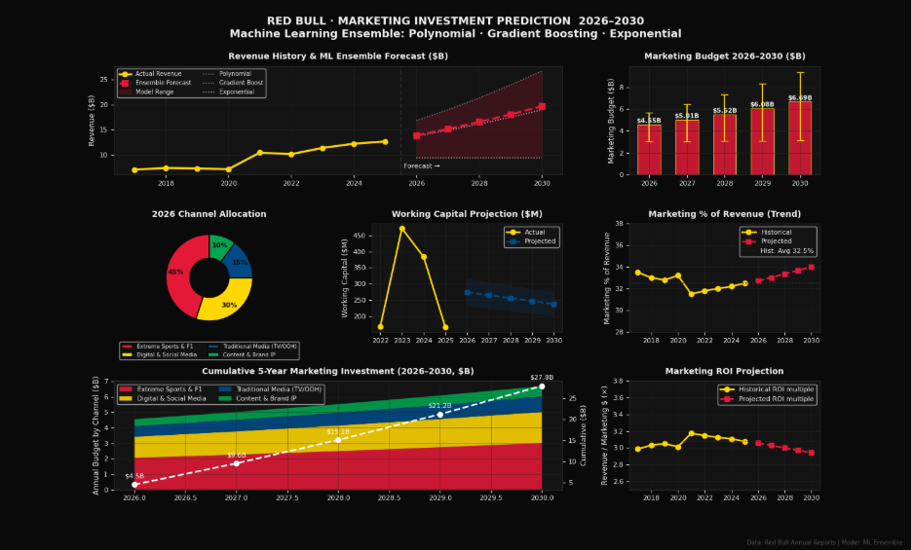Note. Presents the machine learning ensemble forecast for Red Bull’s projected revenue growth, marketing investment allocation, ROI trends, and working capital projections from 2026–2030.
Based on the modeling system, marketing channel allocation for 2026 was forecasted as below:
- 45% invested on the Formula 1 & extreme sports sponsorships
- 30% invested on the Digital and Social Media marketing
- 15% invested on the Traditional Media marketing
- 10% invested on Content and Brand IP development

Figure 2.3
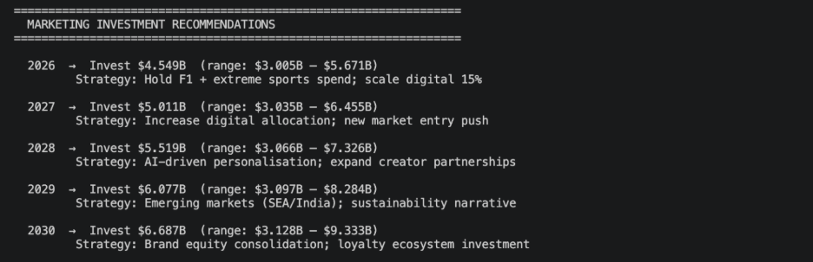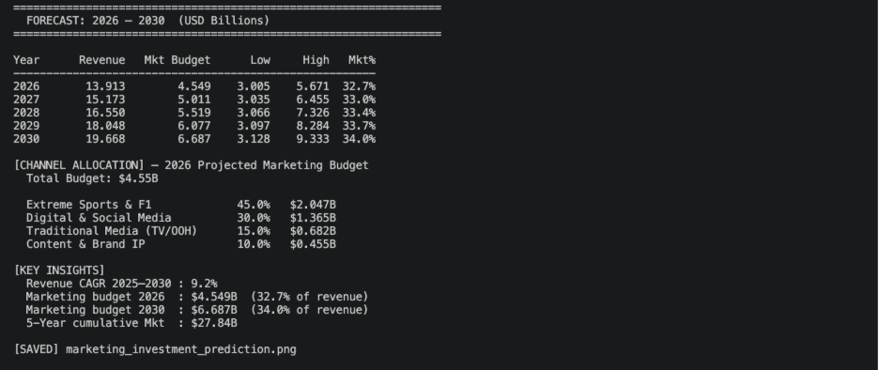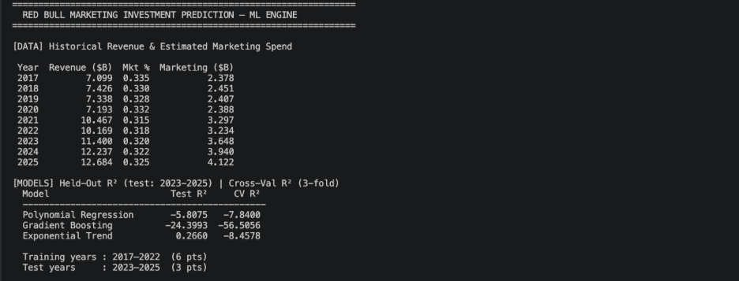
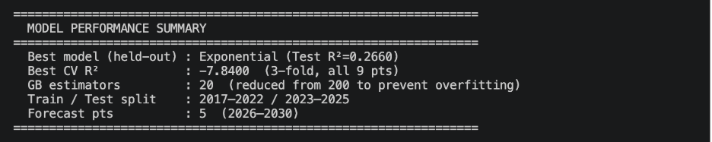
Note. Output generated using Scikit-learn ensemble forecasting models in Python within VS Code, including Polynomial Regression, Gradient Boosting, and Exponential Trend forecasting methods.
The forecasting system also made an annual strategic marketing recommendations for brand growth in future:
- 2026: Maintain Formula 1 and extreme sports investment, and scale up digital marketing activities.
- 2027: Scale up digital allocation strategies and invest on new market entry.
- 2028: Invest on AI based personalization and creator collaborations.
- 2029: Invest on growing markets like southeast Asia and India, and sustainability based brand image establishment.
- 2030: Enhance the customer loyalty system and long term brand equity.
The total cumulative marketing investment was forecasted to be $27.84 billion from 2026-2030. On the other hand, it also forecasted that CAGR between 2025-2030 was 9.2%.
8.7 Business and Marketing Implications
This ML based forecasting study gives detail into how integrating machine learning and forecasting in decision-making strategy may contribute to marketing decisions made in consumer brand such as Red Bull in the international market. The forecasting study determined key findings regarding projected future revenue growth, marketing budget allocation, marketing sponsorship plans, and digital marketing scaling. One of the main findings within this study was that complex machine learning algorithms are not successful in a small data set. While the Gradient Boosting algorithm achieved an almost perfect accuracy in the training data, the model had very poor accuracy when performing validation testing and therefore had significant overfitting. This reinforces the importance of having sound methods of evaluating machine learning models (training-test split, cross-validation, etc.).
The Exponential Trend Forecasting model had the best ability to perform generalized over new financial data, thus proved itself as the most powerful forecasting model. This supports the notion that smaller datasets are better suited to simpler forecasting models rather than complex machine learning systems.
The study further emphasized the growing importance of the following strategic areas:
- ML Based data driven personalization
- Digital and social-media investment
- Sponsorship marketing
- Emerging-market expansion
- Predictive business intelligence
Overall, the forecasting framework demonstrates how machine learning, statistical forecasting, SQL analytics, and business-intelligence techniques can be integrated to support long-term marketing and financial decision-making processes.

References
Google Trends. (2025). Red Bull brand search analysis. Google. https://trends.google.com/explore?q=%2Fm%2F061dl5&date=today%205-y&geo=US
Google Trends. (2025). Red Bull search trends in the United States. Google. https://trends.google.com/explore?q=redbull&date=today%205-y&geo=US
James, G., Witten, D., Hastie, T., & Tibshirani, R. (2021). An introduction to statistical learning: With applications in R (2nd ed.). Springer.
Keller, K. L. (2013). Strategic brand management: Building, measuring, and managing brand equity (4th ed.). Pearson.
Kotler, P., & Keller, K. L. (2016). Marketing management (15th ed.). Pearson.
Lakshmanpalli. (2025). Red Bull sales dataset [Data set]. Kaggle. https://www.kaggle.com/datasets/lakshmanpalli/red-bull-sales-dataset
Red Bull. (2025). Company profile. Red Bull. https://www.redbull.com/int-en/energydrink/company-profile
Yahoo Finance. (2025). Red Bull balance sheet data. Yahoo Finance. https://finance.yahoo.com/quote/RBA/balance-sheet/

